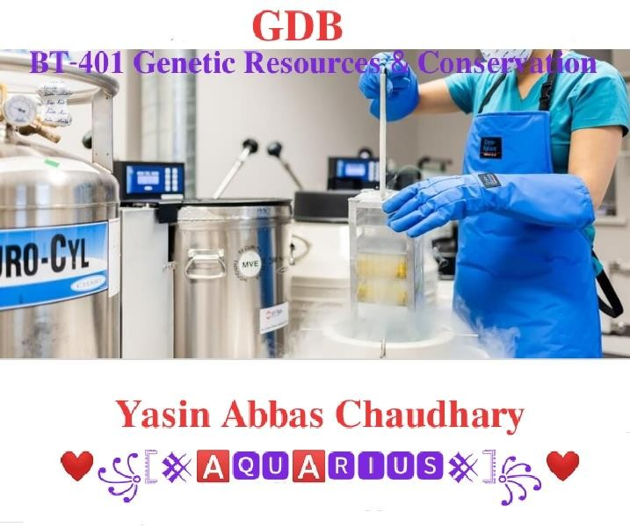

Due Date: 7 July, 2030
Words Limit: 250 Solution:

Cryopreservation:
Cryopreservation is a process that preserves organelles, cells, tissues, or any other biological constructs by cooling the samples to very low temperatures.

Applications:

This method of preservation is widely used in different sectors including cryosurgery, molecular biology, ecology, food science, plant physiology, and in many medical applications.

Types of Cryopreservation:

Slow freezing
The most appropriate storage method of small volumes cryopreservation of several microencapsulated cells. It must be carefully selected that the CPA solution, sample preparation, cooling, thawing and CPA removal.

Vitrification
Vitrification is used in disposal and long-term storage of nuclear waste or other hazardous wastes in a method called geomelting. Waste is mixed with glass-forming chemicals in a furnace to form molten glass that then solidifies in canisters, thereby immobilizing the waste.

Subzero nonfreezing storage
It uses a refrigerating device that generates a variable magnetic field.
Even if without the use of cryoprotectants, the sample would be cooled to a super cooled state.It was verified the method has the ability to suppressing anaerobic metabolism and decrease harm in the hearts of large animals.

Preservation in the dry state.
The ultimate goal is fully realized when stable long-term storage without the use of liquid nitrogen and bulky freezers, It becomes available.
It is prove that increase cell survival at low water contents by loading cells with the protective disaccharide trehalose.

Types of Cryoprotectants:
Cryoprotectant agents are used to prevent ice formation, which causes freezing damage to the biological tissue when cooling the organs.
Permeating agents such as glycerol can move across cellular membranes and modulate the rate and extent of cellular dehydration during freezing-induced membrane phase transitions, such as glycerol, ethylene glycol and dimethyl sulfoxide.
Non-permeating protectants including sugars and proteins are used as bulking agents and to increase the glass transition temperature of the freezing extender.

Regards: VU Expert Zoologists

